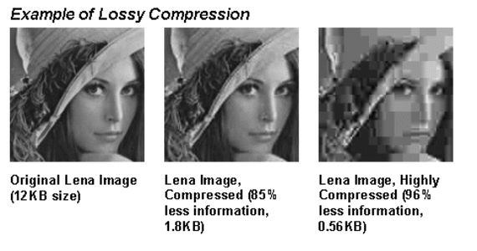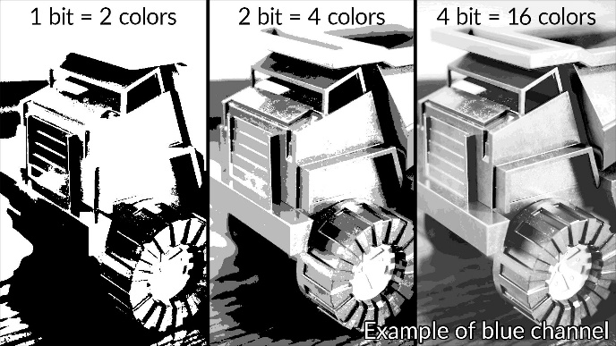

Data Representation: Compression of Images and Text

Name:

|  |  |  |  |
| --- | --- | --- | --- |
| **D** | **File types** | | |
| **PDF** | | document | lossless |
| **PNG** | | image | lossless |
| **JPEG** | | image | lossy |
| **GIF** | | image | lossy |
| **BMP** | | image | uncompressed |
| **MPEG** | | video | lossy |
| **MP4** | | video | lossy |
| **MOV** | | video | lossless |
| **MP3** | | audio | lossy |
| **WAV** | | audio | lossy |

Original: 12KB

|  |  |  |
| --- | --- | --- |
| **B** | **Representing Text** | |
| **ASCII** | | A 7-bit code which represents a basic *character set* |
| **Extended ASCII** | | A *character set* represented by 8 bits instead of 7, in other ways just like ASCII |
| **Unicode** | | A modern standard *character set* which uses 16 bits and includes many international characters |
| **Character set** | | The complete set of letters and symbols available within a given code |

|  |  |  |
| --- | --- | --- |
| **A** | **Key Vocab** | |
| **Compression** | | Reduction in file size to lessen download times and storage requirements |
| **Lossy** | | Compression which loses data (and therefore quality) |
| **Lossless** | | Compression which preserves the original data |
| **Metadata** | | Data about data |

|  |  |
| --- | --- |
| **G** | **Colour depth** |

Compressed: 1.8KB

Very compressed: 0.56KB

|  |  |
| --- | --- |
| **F** | **Lossy compression** |

|  |  |
| --- | --- |
| **E** | **Image metadata** |
| Filename | |
| File format | |
| Dimensions | |
| Resolution | |
| Colour depth | |
| Time and Date | |
| Location | |
| Camera settings | |

|  |  |  |
| --- | --- | --- |
| **C** | **Representing Images** | |
| **Bitmap** | | The representation of an image by converting it to pixels and each pixel to a binary number |
| **Vector** | | The representation of an image by splitting it into shapes and storing each shape as a binary number |
| **Pixel** | | The smallest element of an image. One dot of one colour. |
| **Resolution** | | The level of detail in an image, measured in pixels (dots) per inch (dpi) |
| **Colour depth** | | The number of bits used per pixel to record colour. |
| **File Size** | | width (px) × height (px) × *colour depth* |